Christopher Wilson
8/10/2026
CS-660 Module Six Assignment

- Identify the role of each labeled region in your diagram.
The Java section represents the overall program and contains the heap and stack memory used while the program is running. The heap stores the three Worker objects and the shared static/class data, including the counter variable. Each Worker object contains its thread Id and n values, with Worker 1 having a thread Id of 1 and n of 2, Worker 2 having a thread Id of 2 and n of 2, and Worker 3 having a thread Id of 3 and n of 2. The stack contains the three separate threads, and each thread has its own stack containing the run() method and the recursive fibonacci() calls. The fibonacci(2) method calls fibonacci(1) and fibonacci(0), which returns 1 and 0, resulting in a Fibonacci value of 1 for each thread. The this reference connects each thread to its corresponding Worker object in the heap. The counter is shared by all three threads and starts at 0, with each thread incrementing it once, resulting in a final counter value of 3.

- Explain why constraining stack growth is important in real-world systems.
Constraining stack growth is important in real-world systems because each thread has a limited amount of stack memory. If a program has too many method calls or recursive calls, the stack can continue to grow and eventually run out of memory, causing a stack overflow and crashing the program. Limiting the amount of stack memory that can be used helps prevent this from happening and also makes sure that one thread does not use too much memory. This is especially important in programs with many threads because each thread has its own stack (GeeksforGeeks, 2025; Oracle, 2026).

- Describe a concurrency risk revealed by the diagram.
A concurrency risk shown in the diagram is that all three threads have access to the same shared counter variable. Since the threads can run at the same time and the order in which they execute is not choosen, two threads could try to access and change the counter at the same time. This creates a race condition, where one thread could read the counter before another thread finishes updating it, which could potentially cause an incorrect final value. For example, if two threads both read the counter as 0 before either one increases it, they could both attempt to change it to 1 instead of increasing it to 2. This is a concurrency risk because the result could depend on the timing and order of the threads. The diagram shows this risk because the three separate thread stacks connect to the same shared counter in the heap (GeeksforGeeks, 2026).

- Describe a synchronization technique that would solve the risk you identified.
A synchronization technique that can solve this risk is using the synchronized keyword. The program already uses synchronized with the increment Counter() method. This makes sure that only one thread can run the method at a time. When one thread is updating the shared counter, the other threads have to wait until the method is finished. This prevents multiple threads from changing the counter at the same time and helps prevent race conditions. After each thread safely increases the counter, the final counter value will be 3 because all three threads completed the Fibonacci calculation (Taouam, 2025).

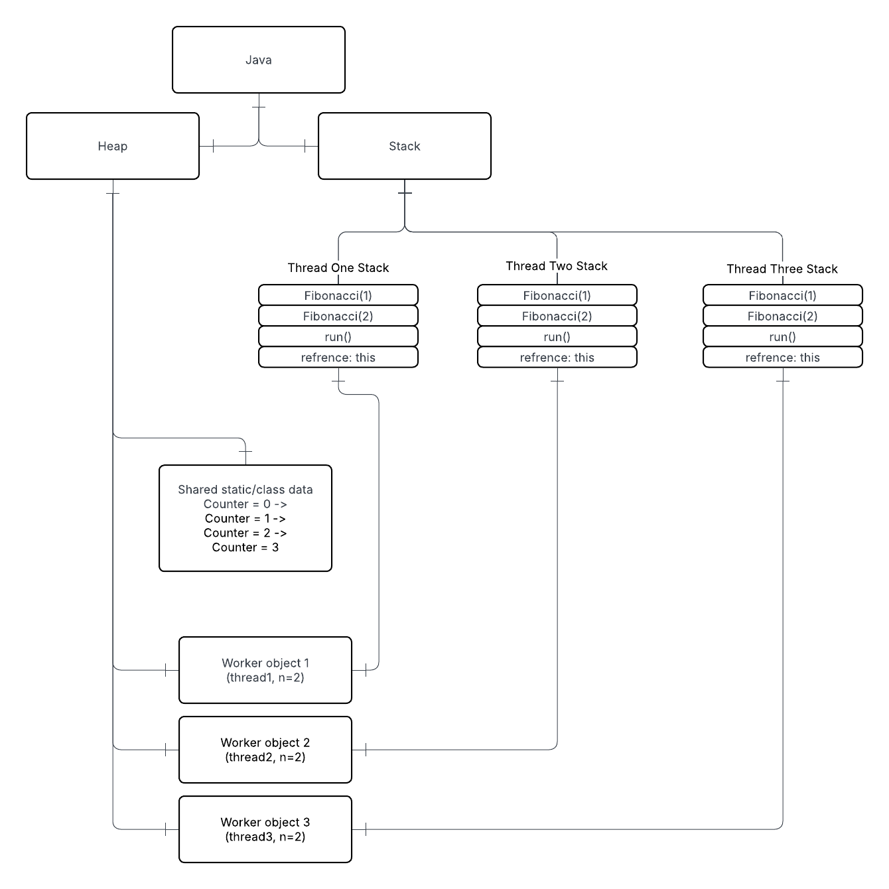

Sources

Ayoub Taouam. (2025, October 2). Avoiding race conditions in java: Tools and techniques. Medium. https://medium.com/@ayoubtaouam/avoiding-race-conditions-in-java-tools-and-techniques-1b172338605a

GeeksforGeeks. (2025, July 23). Is there a limit for the total variables size on the memory stack? GeeksforGeeks. https://www.geeksforgeeks.org/dsa/is-there-a-limit-for-the-total-variables-size-on-the-memory-stack/

GeeksforGeeks. (2026). Concurrency problems in java. In GeeksforGeeks. https://www.geeksforgeeks.org/java/concurrency-problems-in-java/

Oracle. (2026, March 16). StackOverflowError (java SE 26 & JDK 26). Oracle.Com. https://docs.oracle.com/en/java/javase/26/docs/api/java.base/java/lang/StackOverflowError.html

OpenAI. (2026). ChatGPT (GPT-5.6 Luna) [Large language model]. https://chatgpt.com/
Used ChatGPT to find sources needed to answer the questions.

